|  |  |  |  |
| --- | --- | --- | --- |
| **AP CSP Python with Robots**  **Mission 6 Obj 4-6 Assignment** | | **Name:** | |
| **Mission 6 Introduction** | | | |
| Read the introduction and project goals. During this assignment, you will complete the first two goals. | | | |
| **Mission 6 Objectives 4-6** | | | |
| Start Objective 4.  Discuss several ways that ls.check() is different from ls.read().  What is a tuple? |  | | |
| Try Your Skills: Debug Console Use the console panel to experiment with a new **thresh** value. Use the Test Surfaces color blocks.  Type in the console: >>> from botcore import *  Then type: >>> ls.check(0) for each color block and record the tuple.   |  |  |  | | --- | --- | --- | | Black: | Gray: | White: | | | | |
| Complete Objective 4. Use a **thresh** value from the data above.  Set the value of **is_reflective** to detect the line you are using. It will be either True or False | *Do a lot of testing to make sure your program works before continuing to the next Objective.* | | |
| Complete Objective 5. After reading the information in the Objective Panel, use the instructions below to modify the code. |  | | |
| 1. Define the SPEED constant and enable the motors near the top of the code with your other variables. 2. Define a function to move CodeBot. In previous programs, you called the function *go_straight()* or *go_forward()* and both wheels used the same speed. This **drive()** function will give the ‘bot the ability to turn as well as drive forward. Use parameters for two speeds (left and right). 3. In the Main Program, add a **while True:** loop to wait for a button press. 4. Similar to CodeTrek, in the second **while True:** loop, add the **if** statement below the two lines already there. Call the **drive()** function for each branch. The arguments will be the two speeds for left and right. The final else needs to call motors.run() 2 times.   Try doing these steps on your own. Code is included at the end of the assignment, if needed. | | | * SPEED defined * Motors enabled * drive() function defined * ‘Bot waits for button press * Branching if statement added for line control |
| Experiment with your code.  Use a variety of short courses. Some examples of courses are given →  Try the courses at different speeds and record the results. | * Smooth slow curve (left and / or right) * Sharper curve (left or right) * Two curves, left then right * Sharp curve, like a right angle * U-turn curve that turns the bot in the opposite direction | | |
| Add more rows as needed.   |  |  |  |  | | --- | --- | --- | --- | | Speed of CodeBot | Turn direction (L / R) | Type of curve | Result | |  |  |  |  | |  |  |  |  | |  |  |  |  | |  |  |  |  | |  |  |  |  | | | | |
| Complete Objective 6.  What happens if the ‘bot overshoots the line?  What is the fix for this?  Modify the **else** to an **elif**, as directed in CodeTrek. Also, change the 2 motors.run() calls to calling the function instead. (see below) |  | | |
| Now experiment with your code again. Try the courses with the modified code. Add more rows as needed.   |  |  |  |  | | --- | --- | --- | --- | | Speed of CodeBot | Turn direction (L / R) | Type of curve | Result | |  |  |  |  | |  |  |  |  | |  |  |  |  | |  |  |  |  | |  |  |  |  | | | | |
| After Objective 6, turn in this assignment. | | | |

Objective 5 Sample Code:

Use YOUR values for thresh and is_reflective

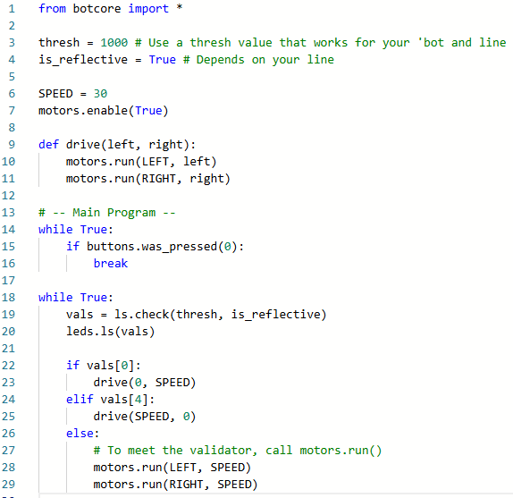

Objective 6 Sample Code:

Modify the if statement:

